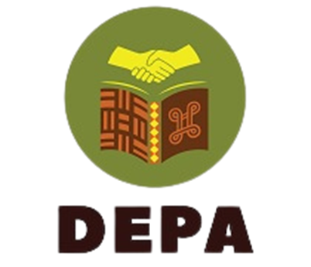

Sensibilities for Engaging in Decolonisation Research

Item |  | Who is responsible for thinking through/addressing/  reporting? | Identified barrier | Support required from larger team
Management
- What role should community members play in the management of the project?

- Should there be a local management team that has local team members who help to shape some elements of the project?

- How do we disrupt the hierarchies within the research teams in meaningful ways while still being effective and accountable in a timely way?

- What are the institutional frameworks that influence decolonisation at University/NGO/State level that we should think through? How far can we address them and how?

Concepts (To be considered in the literature review)
- What is colonial about a concept as practice, policy and theory and why does this matter? E.g. what is colonial about the peace that is being discussed in that context?

- What does decolonisation mean in this instance? What is the version of imposed peace ideas that are being disrupted?

- How can we break the concept down into elements that can be decolonised?

- What resources do we already have for thinking about decolonising the concept? i.e. what do we know; what do we not know; what do we need to know, and what do we need to do?

- What is the relationship between different sites of decolonisation?
- How do we bring together a decolonial conceptualisation of a concept across different countries and contexts?
- What elements of this local peace can be translated and transformed by bringing it together with the meanings of peace in other contexts?

- Who benefits from this reconceptualisation? How have we taken this back to the community?

Data sources
- Local data sources, including grey material
- What material is held within the community libraries?
- Other resources?
- Older people in the community?
- Local references?

- Wider community-based participation
- What do the community members think and talk about in relation to peace? For instance:
- How do mothers convey stories to their children in everyday contexts?
- How do older people relate their pasts in ways that could inculcate pasts?

Methodology
- Choice of methods –
- Have we allowed local research methods to emerge on the ground and in the community?
- Have we engaged with specific age groups in the community to see what arts methods they would use?
- Have we used local artists and art teachers within the communities being studied to work with the communities to allow methods of representation around arts to emerge?

- Have we recorded and jointly interpreted how each group understands their own everyday lived practices around peace?

- Have we used local researchers working in their own languages to access this?

- How have those researchers been represented in the knowledge-making process?

- How have power relations been overturned in this process of working with these groups?

- What learnings have been passed on to the communities themselves in this process? E.g. employ an arts teacher to teach children the form of arts that is being used in the research methods.

- How far do we know how to apply the methods being used in the community and how do we learn these methods from the community?

- How well is it applied – timely, locally attuned, output-oriented?

- Review of whether it is applied in a way that addresses power relations.

Stakeholders
- Appropriate stakeholder engagement
- Who are the different local stakeholders in the community?
- What about in the wider group, i.e. town or country, who might already be working in similar ways?
- How have arts stakeholders been engaged especially those who already have a place in the community? E.g. local drama teacher or local musician?

- How do we maintain an ongoing relationship with these art practitioners and community members so that they feel that their concerns are accounted for, and their interpretations included?

- How are these recorded and shared including with the stakeholders where appropriate?

- What does the wider community and not just the groups being studied gain from this? What is being left behind as a lasting resource?

- How do we reward stakeholders through appropriate communication during the project and also after the project finishes?

Data Analysis and Recommendations
- How do we involve stakeholders in the analysis of the material in their own languages?

- Can we involve community members in dissemination activities?

- How do we involve them without depending on English as a medium?

- How do we develop materials in the languages most meaningful to the group?

- How do we work through the analysis and recommendations phase with the groups involved and in their own language?

- Where does the authority rest?

Dissemination
- Output/outcome
- How are community members involved?
- How are the people interviewed involved?

- Mode of communicating outcomes
- Is it appropriate to the context and people?
- Is it using a locally chosen medium of communication?

- How do we invite communities into forms of dissemination that may not be meaningful to them and should we?

- Inclusive language
- How do we go beyond English language-speaking groups?
- What have we done towards translating into local languages?

Review

